Grove - Slide Potentiometer

(Redirected from [Sliding Potentiometer](http://www.seeedstudio.com/wiki/index.php?title=Sliding_Potentiometer&redirect=no))

|  |
| --- |
| **Contents**   [[hide](javascript:toggleToc())]   * [1 Introduction](http://www.seeedstudio.com/wiki/Sliding_Potentiometer#Introduction) * [2 Features](http://www.seeedstudio.com/wiki/Sliding_Potentiometer#Features) * [3 Application Ideas](http://www.seeedstudio.com/wiki/Sliding_Potentiometer#Application_Ideas) * [4 Specification](http://www.seeedstudio.com/wiki/Sliding_Potentiometer#Specification) * [5 Usage](http://www.seeedstudio.com/wiki/Sliding_Potentiometer#Usage)   + [5.1 Application 1: As A Voltage Divider](http://www.seeedstudio.com/wiki/Sliding_Potentiometer#Application_1:_As_A_Voltage_Divider)   + [5.2 Application 2: As An Adjustable Resistor](http://www.seeedstudio.com/wiki/Sliding_Potentiometer#Application_2:_As_An_Adjustable_Resistor)   + [5.3 Application 3: As A HID Device](http://www.seeedstudio.com/wiki/Sliding_Potentiometer#Application_3:_As_A_HID_Device) * [6 Resources](http://www.seeedstudio.com/wiki/Sliding_Potentiometer#Resources) * [7 Support](http://www.seeedstudio.com/wiki/Sliding_Potentiometer#Support) |

Introduction

This slide potentiometer is a linear variable resistor with a total resistance of 10k. When you move the lever from one side to the other, its output voltage will range between 0 V to the VCC you apply. Three of four Grove pins are connected to VCC, GND and the ADC IN on the slide, while the remaining pin is connected to a green indicator LED. You can use the indicator LED to visually display the change on the potentiometer.   
[Model: COM05231P](http://www.seeedstudio.com/depot/grove-slide-potentiometer-p-1196.html?cPath=156_160)  
[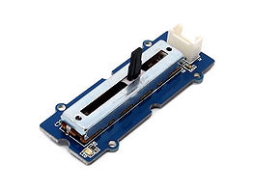](http://www.seeedstudio.com/wiki/File:Sliding1.JPG)

Features

* 30 mm long slide length
* Linear resistance taper
* Grove compatible

Application Ideas

* Voltage divider: a linear circuit that produces an output voltage as a fraction of its input voltage
* HID for controlling panels

Specification

|  |  |  |  |  |
| --- | --- | --- | --- | --- |
| **Item** | **Min** | **Typical** | **Max** | **Uint** |
| **Voltage** | 3.3 | 5.0 | 30 | VDC |
| **Current** | -- | -- | 30 | mA |
| **Dimension** | 24x60 | | | mm |
| **Net Weight** | 8.6 | | | g |
| **Rotational life** | >15,000 | | | cycles |
| **Total resistance** | 10 | | | KΩ |
| **Stroke length** | 30 | | | mm |
| **Total resistance tolerance** | +/- 20 | | | % |

Usage

This slide potentiometer is a linear variable resistor with a total resistance of 10k. When you move the lever from one side to the other, its output voltage will range between 0 V to VCC you apply.

1. Connect the module to the Analog port 0 of Grove - Basic Shield using the 4-pin grove cable.   
2. Plug the Grove - Basic Shield into Arduino.  
3. Plug the Grove - Slide potentiometer onto the Arduino/Seeeduino; Connect the board to PC using USB cable.

[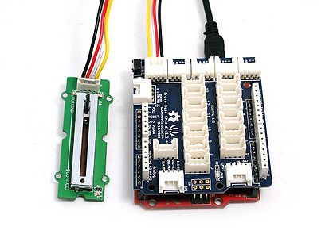](http://www.seeedstudio.com/wiki/File:Sliding2.JPG)  
(图片更新)  
4. Connect Arduino to PC by using a USB cable.

**Application 1: As A Voltage Divider**

Copy and paste code below to a new Arduino sketch. Then upload the code to Arduino. Please click [here](http://www.seeedstudio.com/wiki/Upload_Code) if you do not know how to upload.

int adcPin = A0; // select the input pin for the potentiometer

int ledPin = A1; // select the pin for the LED

int adcIn = 0; // variable to store the value coming from the sensor

void setup()

{

Serial.begin(9600); // init serial to 9600b/s

pinMode(ledPin, OUTPUT); // set ledPin to OUTPUT

Serial.println("Sliding Potentiometer Test Code!!");

}

void loop()

{

// read the value from the sensor:

adcIn = analogRead(adcPin);

if(adcIn >= 500) digitalWrite(ledPin,HIGH); // if adc in > 500, led light

else digitalWrite(ledPin, LOW);

Serial.println(adcIn);

delay(100);

}

Open the serial monitor，you can see some data from ADC.   
[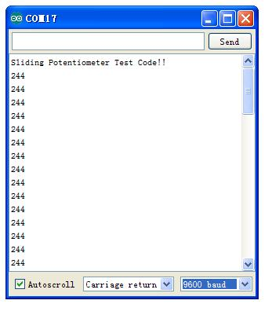](http://www.seeedstudio.com/wiki/File:Sliding_com.jpg)  
Move the lever back and forth, the serial data will change correspondingly. When the output resistance exceeds a preset value, the indicator LED will light up.

**Application 2: As An Adjustable Resistor**

As shown below, the Grove - Slide Potentiometer can be used as a simple slide potentiometer.

[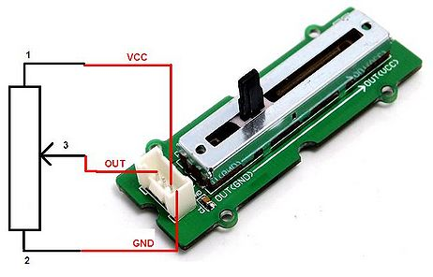](http://www.seeedstudio.com/wiki/File:Sliding_justr.JPG)

**Application 3: As A HID Device**

Slide Potentiometer can be a nice HID device as we used on the following RC toy car. We added two Slide Potentiometers on the control panel to control the speeds of the left and right wheels of the toy car respectively. For example, when the right wheels spin slower than the left, the car will turn right.

[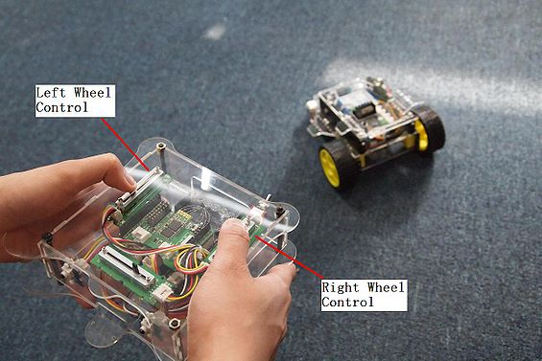](http://www.seeedstudio.com/wiki/File:Car.JPG)

Resources

* [Sliding Potentiometer Eagle File](http://seeedstudio.com/wiki/images/1/11/Sliding_Potentiometer.rar)
* [Sliding Potentiometer in PDF](http://www.seeedstudio.com/wiki/images/e/ed/Sliding_protentiometer_sch.pdf)
* [Sliding Potentiometer datasheet](http://www.seeedstudio.com/wiki/images/1/13/Sliding_potentiometer_datasheet.pdf)